Overvoltage And Undervoltage Protection System

This project aims to build a system that monitors voltage and provides a breakpoint based low and high voltage tripping mechanism that avoids any damage to the load. Various industrial and domestic systems consist of fluctuation in the AC mains supply. There is a chance of damaging electronic devices that are quite sensitive to these fluctuations. So there needs to be a tripping system that avoids any damage to these loads.
Our system consists of a tripping mechanism that monitors the input voltage and trips according to limits provides. Here we use a quad comparator IC with two more comparators to be used as window comparators to it. Well the system delivers an error as soon as the input voltage falls out of the window range. This trigger then operates a relay that cuts off the load to avoid any damage to it. We here use a lamp to demonstrate as a load. Well the system is also configured with an alarm that goes on as soon as tripping takes place.

Block Diagram:
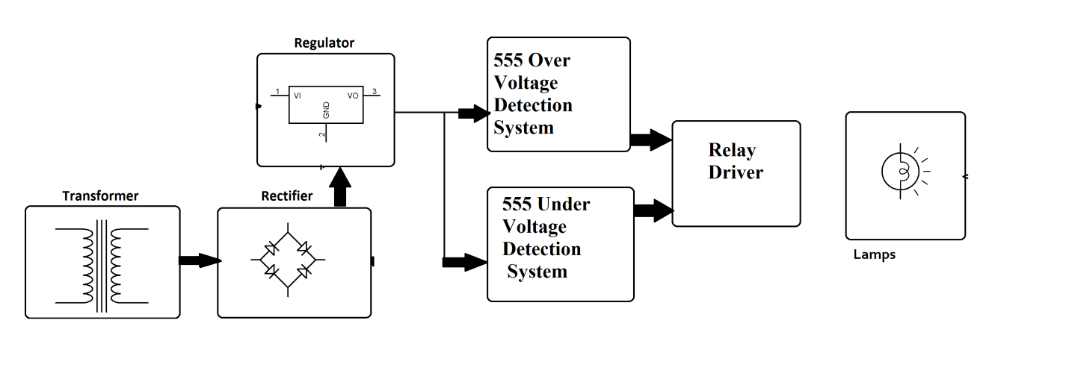
Hardware Specifications:
- Comparator
- Transformer
- Crystal
- Voltage Regulator
- Lamp
- Potentiometer
- Capacitors
- Diodes
- Resistors
- Relay
- LED

