Short Circuit Indicator Project

Short circuit condition is a condition in which the input terminals of a power supply get in electrical contact with each other causing huge current flow. This leads to very large heat generation which can damage the system and also pose a threat to people nearby it. Thus short circuit condition is necessary to be detected and be attended immediately. Short Circuit Indicator Project does the task of detecting the short circuit in a circuit in which it is connected automatically. With the help of regulator and a pair of transistor we lit up an indicator LED that glows only when there is short circuit event occurring. In this way one can easily understand the short circuit condition and take appropriate measure of cutting off the power supply and removing the short circuit. We have demonstrated the short circuit in our circuit board using a wire piece which has very low, close to zero value of resistance thus creating a short circuit at the source connector.

Block Diagram:
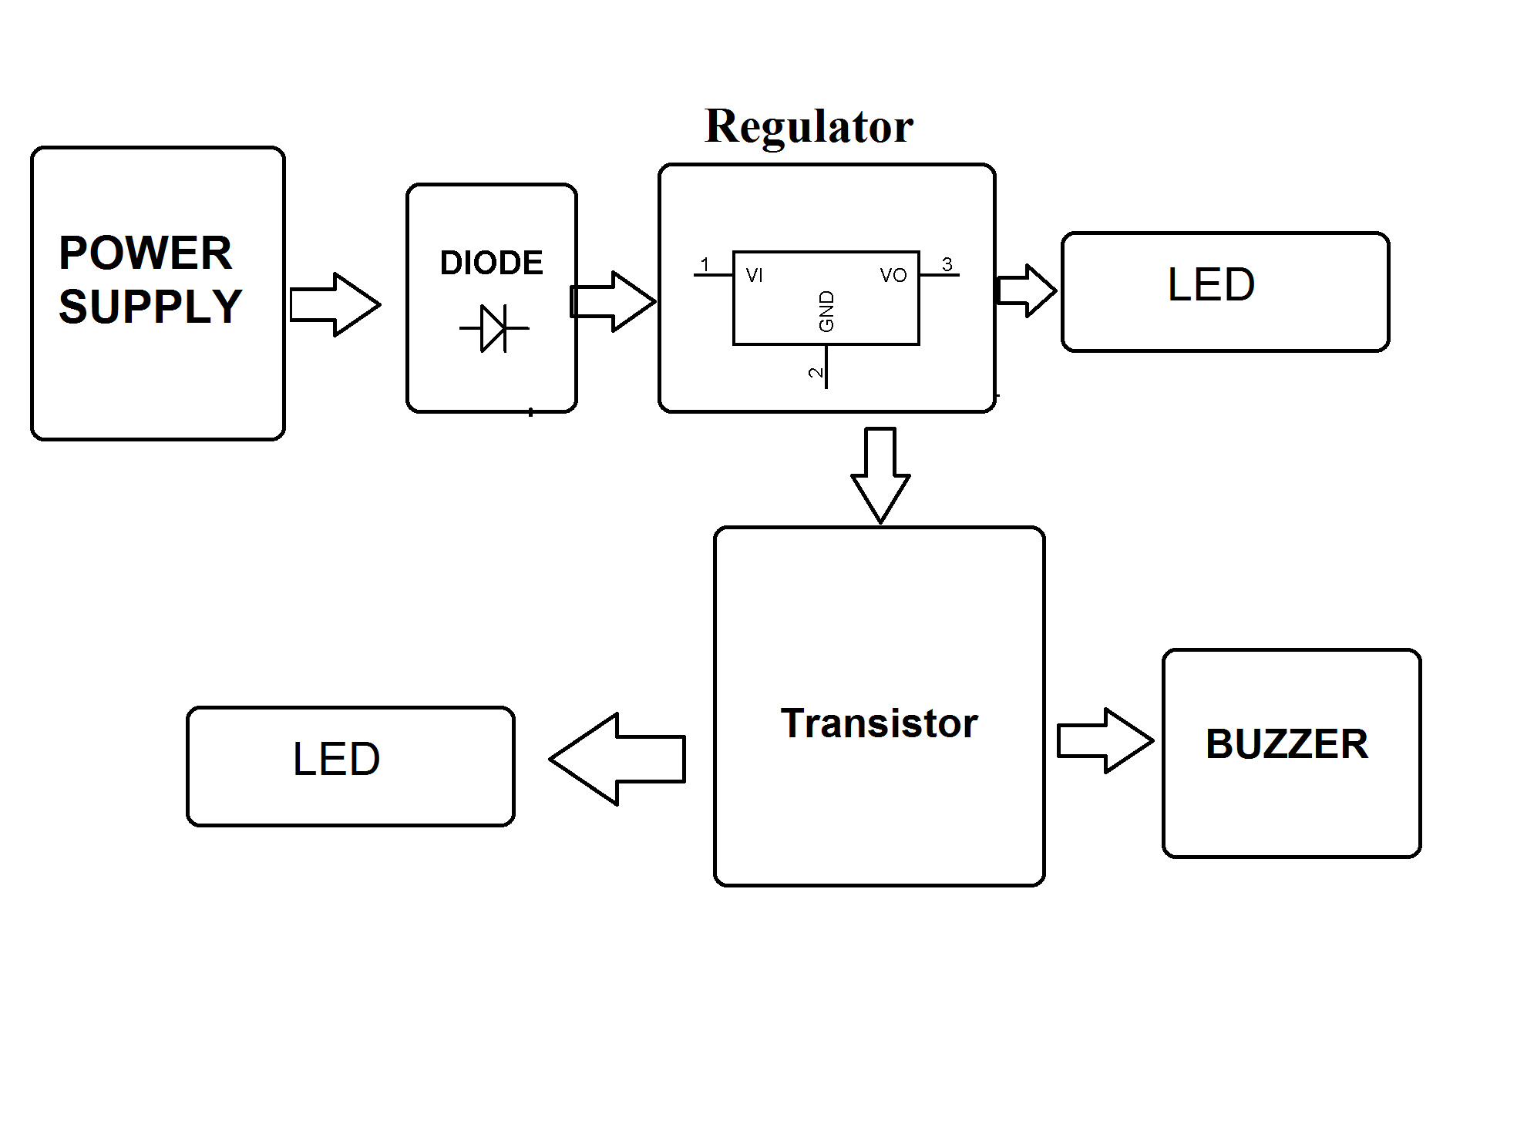

Hardware Specifications

- Buzzer
- Resistors
- Capacitors
- Transistors
- Cables & Connectors
- Diodes
- PCB
- LED’s

