Agricultural Pesticide Sprayer & COVID Sanitization Drone

Agricultural pesticide spraying is a very labour intensive task with various problems faced in manual process. Human spraying may lead to inadequate or spraying of pesticides in certain parts of field, also it is not safe to handle pesticide as exposure can cause skin and breathing problems in humans. The same problem is with sanitization in city or towns during COVID pandemic. Drones are very costly pieces of equipment, using drones for just one purpose proves to be very expensive task.
To solve all these problems we here design a multipurpose drone that is compact and thus less costly and also multipurpose drone that can be used in agriculture spraying as well as for sanitization of streets/ corridors/ open areas. Making it multipurpose makes it even more worth to buy as it fulfils more than one purpose.
This Multipurpose sprayer drone provides the following advantages:
- Dual purpose usage for agriculture as well as sanitization
- Long range RC control & easy to Operate
- Low cost spraying drone
- On board camera for live monitoring
- No possibility of harm to humans from pesticide exposure
- Equal distribution of pesticides throughout the field
- Ability to spray large fields within minutes
- Easy to sanitize open areas for COVID sanitization

The system makes use of 6 motors to fly this hexacopter drone with enough thrust to lift the pesticide/sanitizer chemical tank. The drone is operated by an RC remote that is used to transmit commands over the RF spectrum over to the drone controller. The drone controller is interfaced with an RC receiver used to receive drone control commands from rc transmitter remote.
The commands include drone direction control commands or the drone sprayer control commands. The drone controller uses the flight control commands and operates the motor speeds through esc’s to operate the drone flight and achieve the desired flight motion. The controller on receiving the sprayer control commands operates the sprayer motors in order to control the drone spraying. The drone can spray in medium or full range which allows the user to control the amount to be sprayed through the field.
Thus the multipurpose sprayer drone allows for dual purpose spraying over agriculture fields as well as over city for sanitization purposes.

Components:
- Drone Motors
- RF Camera
- Pesticide Tank
- Spray Motors
- Sprayer Pipes
- Pipe Fittings
- Motor Mounts
- RC Remote Controller
- Propellers
- Drone Controller
- RF Receiver
- Drone Frame
- Electrical & Wirings
- Mounts and Joints
- Base Frame
- Supporting Frame
- Screws and Fittings

Applications:
- Agriculture pesticide spraying
- Open Area/Street/Corridor/Airport/Railway Station etc Sanitization

Advantages:
- Dual purpose usage for agriculture as well as sanitization
- Long range RC control & easy to Operate
- Low cost spraying drone
- On board camera for live monitoring
- No possibility of harm to humans from pesticide exposure
- Equal distribution of pesticides throughout the field
- Ability to spray large fields within minutes
- Easy to sanitize open areas for COVID sanitization

Disadvantages:
- It requires battery charging
- It has a limited range for Live Streaming and Controlling

Block Diagrams:

Front View
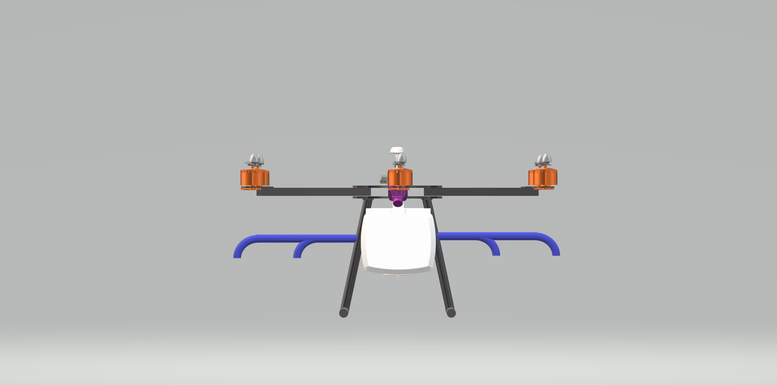

Side View
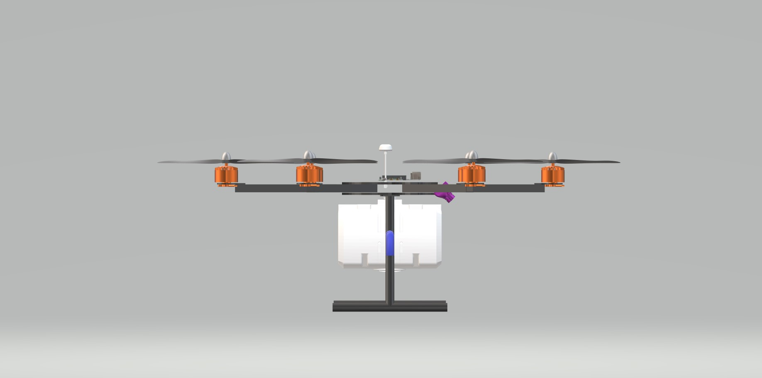

Field Operation

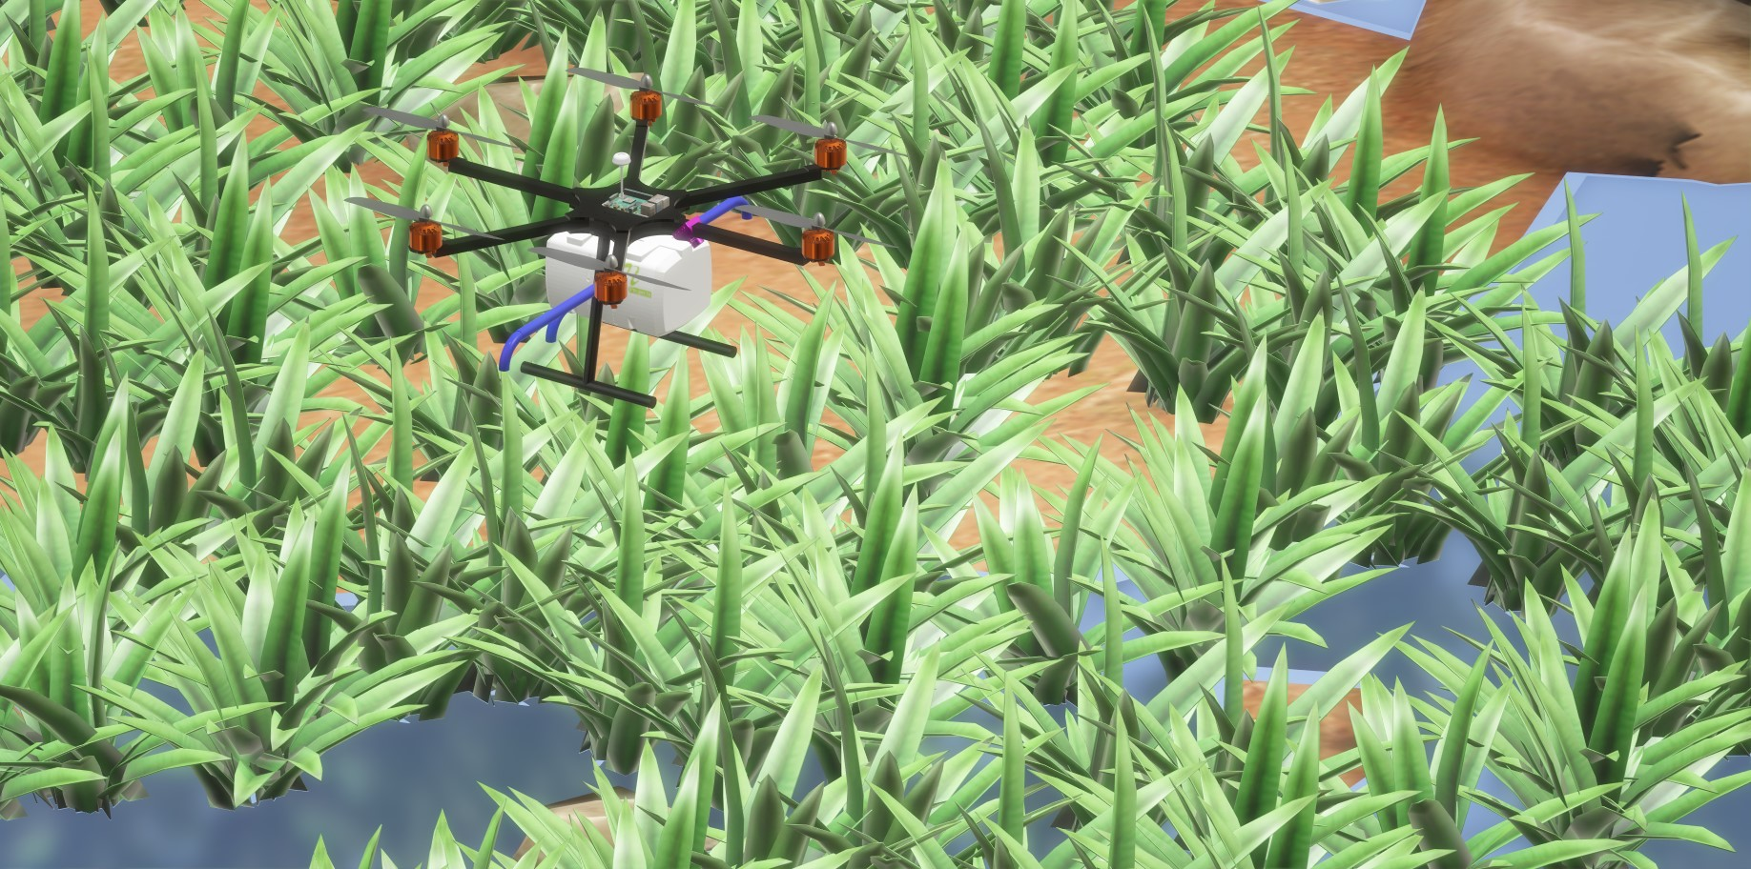

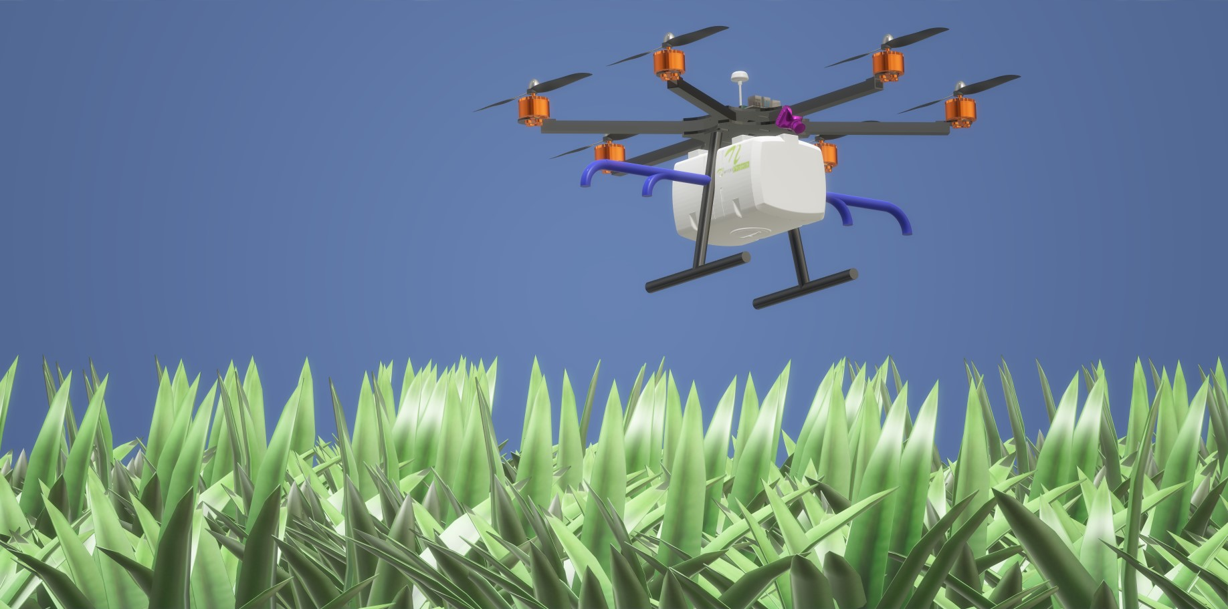

Street Operation



