Power Generation Using Electromagnetic Suspension

The power generator electromagnetic suspension system is a system that converts vehicle bump generated linear motion & vibration, into electricity to be used in battery charging. General vehicle shock absorbers are used to simply absorb this energy without converting it to electricity. So here we put forth a way to use this free energy and store it for further needs such as vehicle lights, cooling, indicator lights etc. To achieve this we here use the principles of electromagnetism in order to generate electricity from this motion. Our shock absorber is made up of a metal shaft, spring, magnet, coils, base with screws and joints. It uses a coil wound around in particular turning arrangement over the inner beam of the part. We use cylindrical supports in order to minimize friction and ensure smooth generation. The head of the absorber consists of magnets attached to outer core which are aligned with inner core to ensure smooth motion while ensuring efficient generation. This arrangement is fitted with springs in a precise manner so as to achieve the desired motion and magnet coil overlapping which allows for generation of electricity through electromagnetism principle. Thus our system puts forward a smart power generation system using electromagnetic suspension system.

Block Diagram:
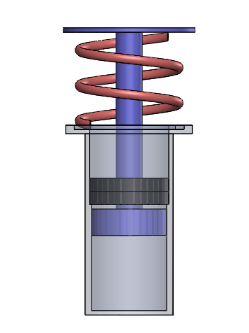
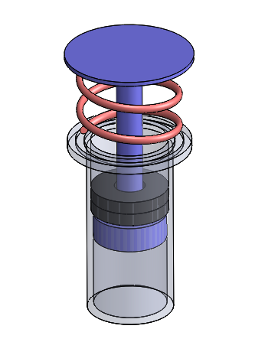

Components
- Metal Shaft
- Spring
- Inner Rod
- Magnets
- Copper Coils
- Frame Base
- Screws & Joints

Advantages
- Free Energy Generation
- Low Maintenance Part
- Energy Saving

