Design and Analysis of Compressor Fins Thermal Distribution

Abstract:
Most of the air compressors are either reciprocating piston type or rotary vane screw. Centrifugal Compressors are common in very large applications such as supply a high-pressure clean air to fill gas cylinders, supply a large amount of moderate pressure air to power pneumatic tool. In air compressor heat can be generated by two ways, heat produced by friction as well as by due to compressing of air at high pressure. So, this heat will transfer to the atmosphere by fins.
To determine the heat transfer rate related to a fin, we tend to should initial get the temperature distribution on the fin. In this work, we altered geometrical shapes of fins for analysis and select the most effective cooling fin. Finite element method (FEM) is an important numerical technique used in engineering analyses. In this project Rectangular, triangular, concave, and convex profile fin of Aluminium nitride and Aluminium alloy A204 were preferred for analysis. Analysis the parameters such as heat transfer rate through the fin, fin efficiency and effectiveness through free and forced convection heat transfer mode. Insulin Heat flux & Aluminium, Aluminium nitride is compared with Aluminium Alloy A204. The varying parameters are considered in the study, by changing the shape of the fin to Rectangular fin, Triangular fin, Page 140 Convex fin, & Concave fin, the weight of the fin body reduces thereby increasing the heat transfer rate and efficiency of the fin. The results show, by using Concave fin with material Aluminium Alloy A204 is better since the heat transfer rate of the fin is more. By using Concave fins, the weight of the fin body reduces compared to existing rectangular engine cylinder fin.

Components:
- Compressor fin

Block Diagrams:
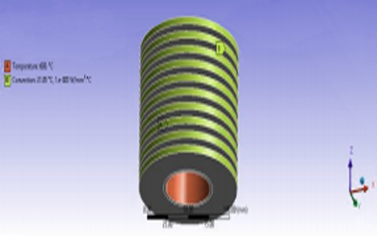
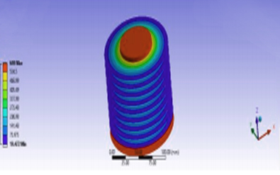

Advantages:
- The effectiveness of a blade can improve by changing the geometry of balance.
- The amount of conduction, convection, or radiation decides the temperature and flow of the heat.
- Human power is not necessary.
- Maintenance is low

