AC Power Strength Controller System

The project aims at controlling the AC power by using the concept of firing angle control of thyristors. One can enter the required percentage of power supply through a keypad. The input is provided to a microcontroller of 8051 family that initiate the firing angle to adjust the load power. For matching the power to the required one, a TRIAC is used in series with the AC load. A LCD screen is used to display the power percentage that is provided by the user.
This system overcomes the faults in the present system and provides a solution for light illumination control mechanism of the lamp. This system is built by using an 8051 microcontroller and based on the principle of firing angle control of thyristors, which in turn can control the illumination of lamp. An LCD display unit is used, which displays entered percentage of the illumination through a matrix keypad. The firing angle control of thyristors is done by the microcontroller, according to the desired percentage entered by the user. Based on this input the microcontroller will automatically adjust the power delivered to the lamp through a solid state switching mechanism.

Block Diagram:

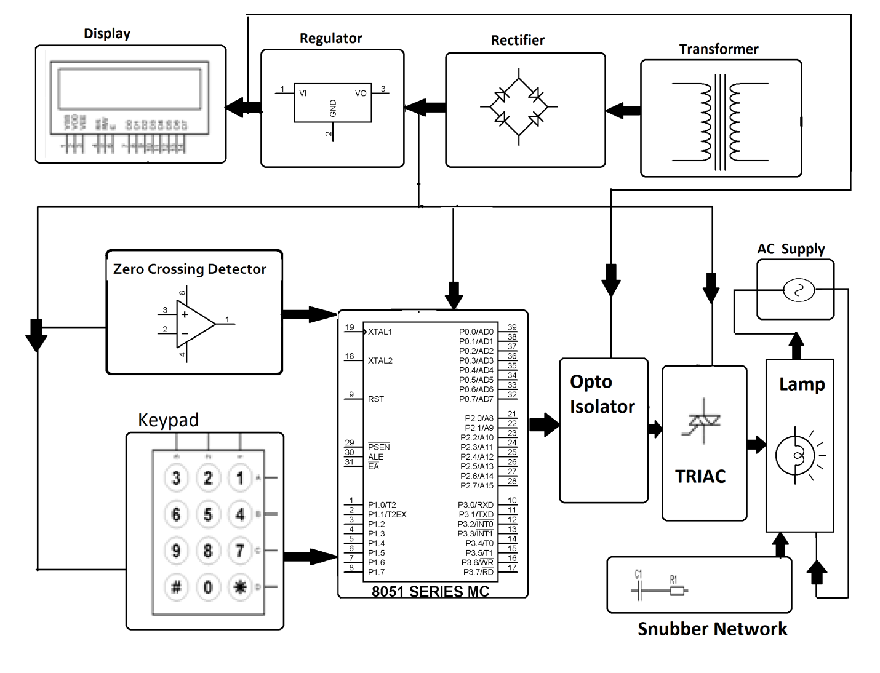

Hardware Specifications
- 8051 series Microcontroller
- Transformer
- LCD
- Voltage Regulator
- Diodes
- keypad
- TRIAC
- Opto Isolator
- Lamp

Software Specifications
- Keil µVision IDE
- MC Programming Language: Embedded C

