Android Circuit Breaker Project

This project provides a password based circuit breaker system using an android application. Here we connect the circuit with android application through which we enter the password. There is a substantial increase in the number of fatal accidents involving line men due to electric shocks resulting from the lack of coordination between maintenance staff and the electric substation staff.
This system provides a solution to this problem, to ensure there are no such incidents that endanger the life of line men. Here the control of the circuit is provided at the substation. The line man can enter the password to switch OFF the circuit.
He may now safely work out the repairs and may return to the substation to switch ON the circuit.
He again needs to enter the password in order to switch ON the circuit.
Since the control to switch ON/OFF the circuit lies with the lineman himself there is no chance of accidents. The system also provides password storage using EEPROM. This system also makes it possible to change the password as and when needed for security purposes.

Block Diagram:
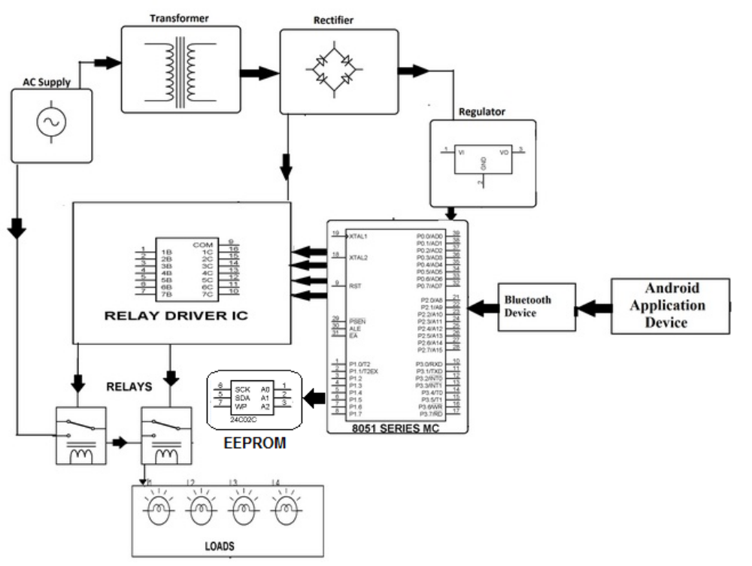
Hardware Specifications
- 8051 series Microcontroller
- Relay Driver IC
- Relays
- EEPROM
- Voltage Regulator
- Bluetooth Module
- Transformer
- LED
- Lcd
- Diodes
- Lamps
- Crystal
Software Specifications
- Keil µVision IDE
- MC Programming Language: Embedded C

Bluetooth Overview

Hardware features
Typical -80dBm sensitivity
Up to +4dBm RF transmit power
Low Power 1.8V Operation ,1.8 to 3.6V I/O
PIO control
UART interface with programmable baud rate
With integrated antenna
With edge connector

- Wireless technology for short-range voice and data communication
- Low-cost and low-power
- Provides a communication platform between a wide range of “smart” devices
- Not limited to “line of sight” communication

It is preferable to use bluetooth because nowadays people have their smartphones with them all the time, since the smartphones have bluetooth facility in them, thus it's better to use bluetooth rather than using RF remotes or IR remotes. Have you ever seen people carrying remotes???
Using bluetooth has many of its own advantages :
1.It's secure.
2.Easy to use.
3.It works in short distance range(i.e. upto 10mtrs.)
4.Anyone can find free bluetooth apps on android and many more.

