GPS Vehicle Tracking & Theft Detection

The project proposes a GPS based vehicle tracking system that tracks the vehicle and sends the tracking data over through a sms.
The microcontroller acts as the controlling head of the system.
When the system goes in Theft mode the authorized user gets the alert message and user will Able to stop the vehicle engine immediately via sending sms to system With ‘S’ Keyword.
The system includes a GPS modem that tracks the vehicle location in the form of latitude and longitude.
This location can be accessed via sms that is being sent to the user.
With the help latitude and longitude information SMS user will able to locate vehicle with Google map.
This system proves very beneficial for transport and travel companies as they can now keep track of their vehicles.

Block Diagram :
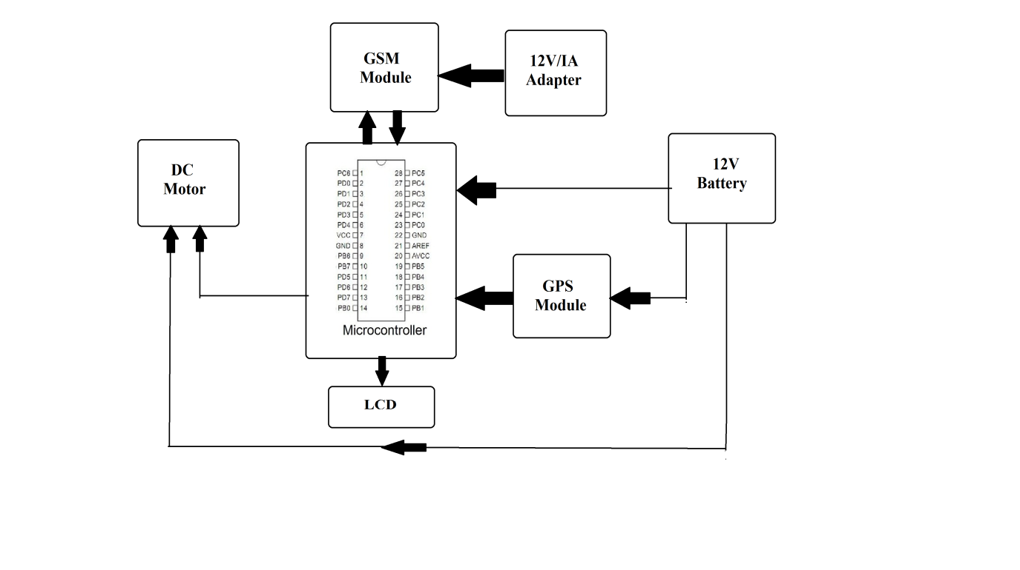
Hardware Specifications
- GSM Modem
- GPS Module
- LCD Display
- Atmega328 Controller
- DC Motor
- LED’s
- Resistors
- Capacitors
- Diodes
Software Specifications
- Arduino Compiler
- MC Programming Language: C

Reference
- http://ieeexplore.ieee.org/xpl/articleDetails.jsp?arnumber=7033987&newsearch=true&queryText=vehicle%20tracking%20theft

- http://ieeexplore.ieee.org/xpl/articleDetails.jsp?arnumber=7062814&newsearch=true&queryText=vehicle%20tracking%20theft

