Prepaid Energy Meter Using PIC

Prepaid energy meter allows the amount of energy to be used as long as the account has balance pending, unlike most of the energy meter which are designed to bill as per the units of energy consumed. Prepaid energy meter allows the user to recharge the account using GSM. The system moniters the amount you recharged and when the energy exeeds the amount the supply is cut off. The prepaid energy meter can be widely used to provide a new and more customized billing system, where users may recharge when they intend to use that facility. the system is built in with a GSM modem which allows the user to remotely recharge the account via SMS. This helps in innovation of electricity billing system and “USE AS NEEDED” electricity usage scheme. This system eliminates the task of manualy reading the meter.

Block Diagram :
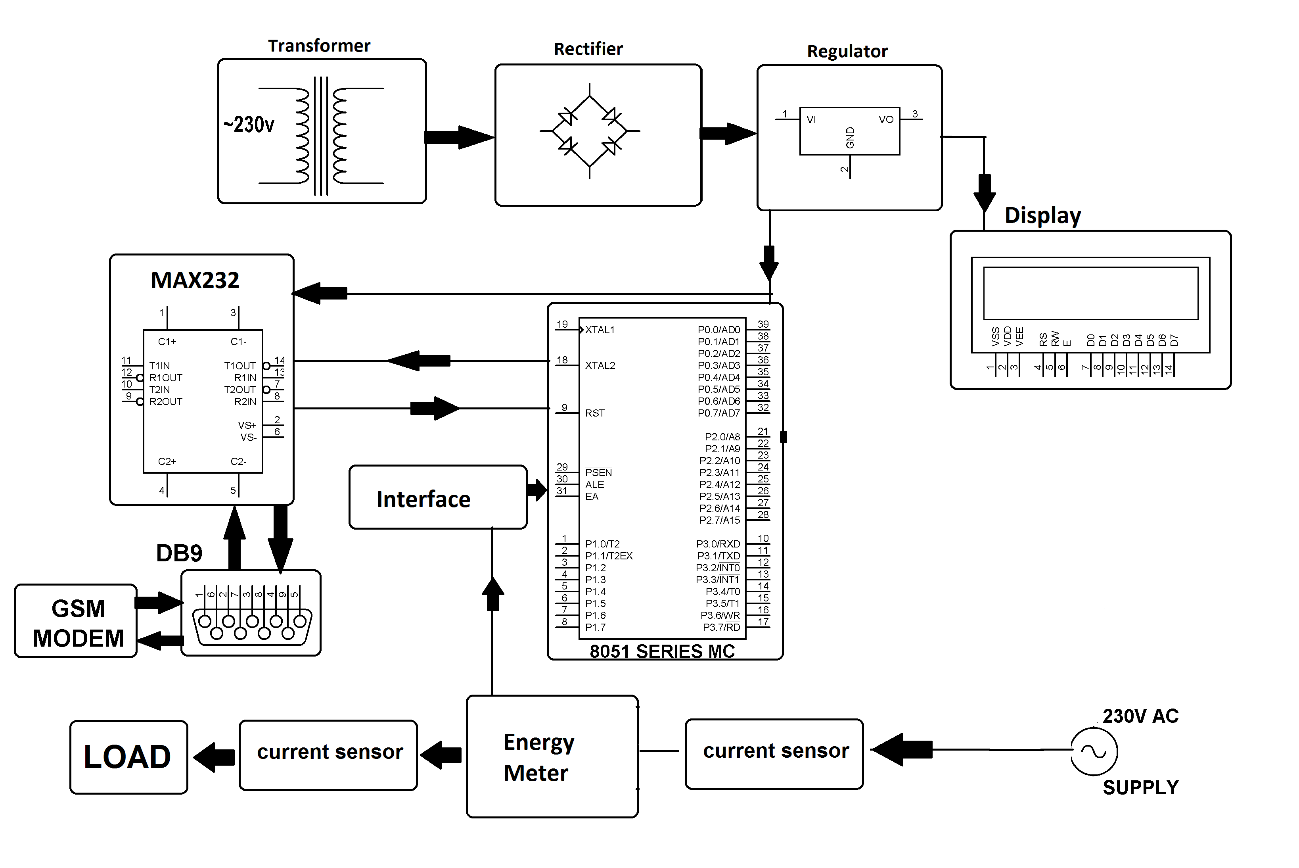

Hardware Specifications

- PIC16F877A
- Relay
- Relay Driver IC
- Vtg Regulator IC
- IC Socket
- GSM Module
- LCD’s Crystal Oscillator
- Resistors
- Capacitors
- Transistors –
- Cables & Connectors
- Diodes
- PCB
- LED’s
- Transformer/Adapter
- Push Button
- Energy Meter

Software Specifications

- MPLAB
- MC Programming Language: Embedded C

