Remote Control Plant Watering System Using 8051

This is the mini project designed to control Plant watering using a standard TV remote. IR sensor is interfaced to the control unit for sensing the IR signals transmitted by the remote. This data is conveyed to the control unit which switches the DC water Pump on or off as desired. An 8051 series microcontroller is used in this project as control device.
Hence with this mini project one can water the plant easily only by pressing some buttons on his TV remote.

Block Diagram

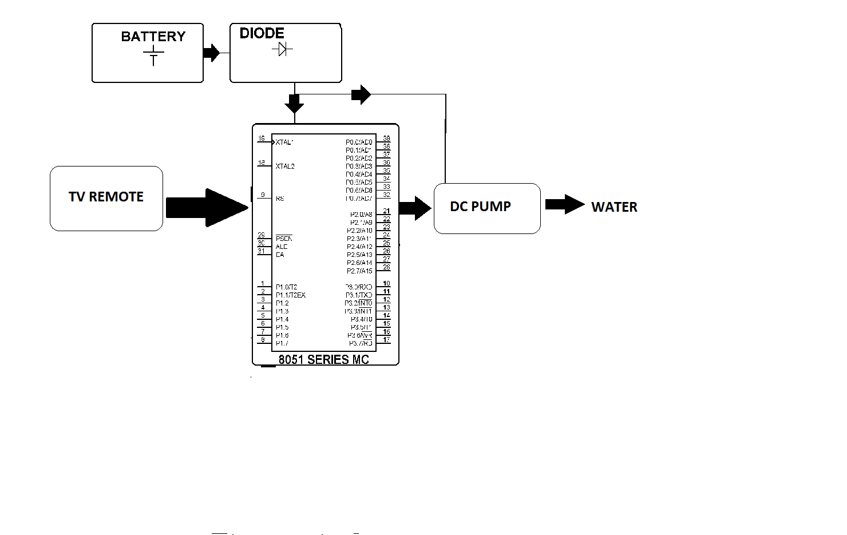

Hardware Specifications

- 8051 Microcontroller

- Pump Motor

- IR Receiver

- Relay

- Crystal Oscillator

- Resistors

- Capacitors

- Transistors

- Cables and Connectors

- Diodes

- PCB and Breadboards

- LED

- Transformer/Adapter

- Push Buttons

- Switch

- IC

- IC Sockets

Software Specifications

- Keil Compiler

- MC Programming Language: C

