CoronaVirus Sterilizer Box | Food Mask Sterilizer

Covid19 changed all of humankind in 2020. Due to its fast and efficiently spreading nature, we were forced to use face masks and gloves to protect from everything we touch. Well we can use masks to protect us outside but what about the things we bring home from market or things we exchange with other people. For example: We cannot apply sanitizers on fruits, vegetables, packed food, batteries etc we buy from outside or we cant sanitize files, paperwork that doctors exchange with patients or employees exchange with each other.
Well we solve this huge problem with a smart electronics system powered by an arduino. We design a 60 degree disinfection box using ultraviolet sterilization to solve the issue. The system makes use of 8 uv c tubes to achieve this task. Now UV C has been proven to kill all viruses within a matter of seconds:
Here are proofs of the concept
https://www.sciencedaily.com/releases/2020/09/200922135749.htm
https://www.healthline.com/health/does-uv-kill-coronavirus#uvc-light-and-coronavirus
http://en.nhc.gov.cn/2020-03/18/c_77915.htm
The Arduino COVID Disinfection box has the following Key Aspects
- 360 Degree Disinfection
- Proven to Deactivate all CoronaViruses
- Automatic Timer based Shutoff and Alerting
- Can Sterilize Mask, Packed Food, Electronics etc
- Variable Sterilization Timer Setting
- Automatic Safety Shutoff
- Easy To Use
- No Water No Chemicals | Environment Friendly
The Arduino controller takes user input for time setting and starts sterilization when start button is pressed. It automatically shuts off when the sterilization time is completed. Also an automatic shutoff system shuts off the sterilization if lid is opened by user between ongoing sterilization.

Components
- Arduino Uno
- LCD Display
- Buzzer
- Lid Sensor
- UV-C Tubes
- Buttons
- Metal Mesh
- LED’s
- IC’s
- Resistors
- Capacitors
- Diodes
- Transistors
- Transformer
- Base frame
- Supporting Frame
- Mounts and Joints
- Screws and Bolts

Advantages
- Dry Sterilization Without Water or Chemicals
- 360 Degree Sterilization
- Proven for Bacteria and Virus Deactivation
- Adjustable Sterilization Time
- Automatic Safety Shutoff if opened untimely

Disadvantages
- It has a limited size so cannot sterilize large objects
- It is AC power operated not battery operated so cannot be taken in a car

Block Diagram
Front View

Side View


3D View
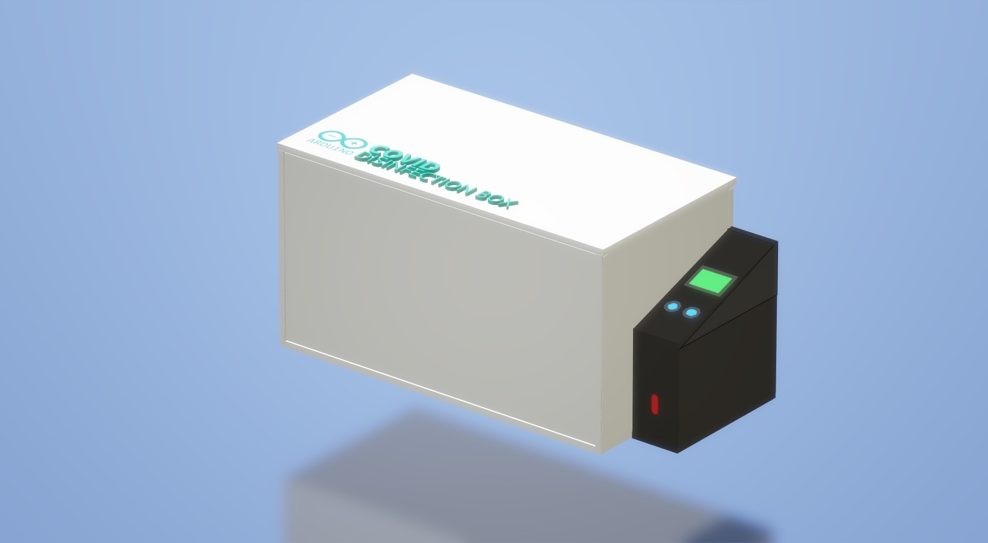
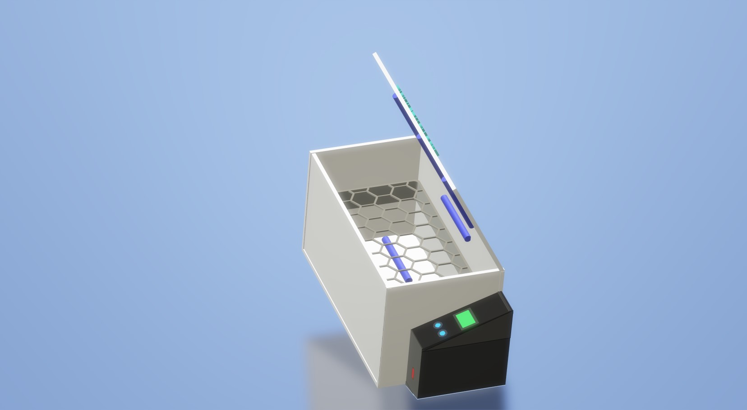

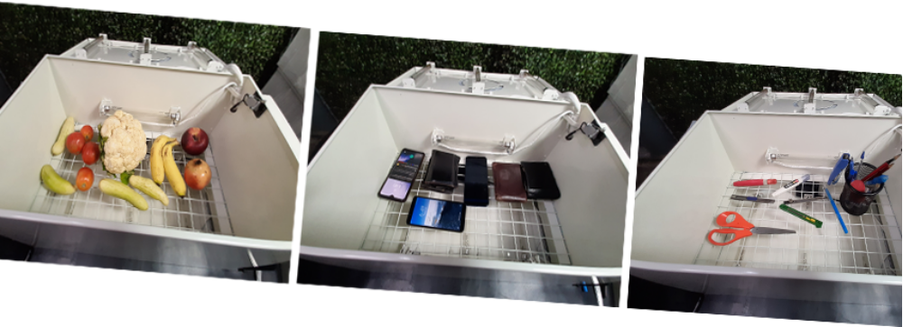Usage for Food, Phones, Stationery etc Sterilization

