Vet Care App

- Background/ Problem Statement

Veterinarians are medical professionals who manage reproductive health and injuries in animals. Moreover, Vets also play a vital role in ensuring animal reproduction, animal health management, conservation, breeding and preventive medicine like animal nutrition, bio security, etc.
Providing adequate veterinarian care is undeniably crucial to ensure the health and wellbeing of animals.
Developed using flutter, this Vet Care App helps users connect with their veterinarians with ease.
This system consists of three entities; The Doctor, The Assistant, and the User.
The User can add their pets and manage their information. User can also book appointments for their pets using this application. Users can even use this application to notify regarding emergencies
Doctors can use this application to approve/reject appointments and allot users with a suitable slot.
Doctors can also answer any queries asked by the user.
Doctor’s assistant can view the list of scheduled visits along with the nature of the visit.

- Working of the Project

In this system, the User can book an appointment for a vet, the appointment has a lot of details to put on, like nature of appointment, doctor can update if any sample needs to be collected wherein, he can appoint an assistant to go and collect or doctor home visit is required etc. Doctor and the user can ask queries with respect to the appointment, its not a chat module.

- Advantages
  - Appointment can be doctor visit or home visit
  - Doctor can send someone to take any sample of the pet
  - Appointments can be cancelled within a period
  - Includes an option for Emergency in nature of appointment.

- System Description
The system comprises of 3 major modules with their sub-modules as follows:
Doctor:
- Register:
  - Doctor can register using personal details.
- Login:
  - Doctor can login using id and password.
- Change Password:
  - can change the password within app
- Manage Assistance Account:
  - Add/update/delete/view Assistance Account.
- View Appointments:
  - list of appointments & details.
  - Approve/Reject or change date/time of the Appointment
  - Allot Assistance to pick any sample etc if any
  - Mark if any doctor home visit is necessary
  - Queries – doctor can ask or reply on a query

Assistance:
- Login:
  - Assistance can login using id and password.
- View Visits:
  - list of visits for today.
  - details & nature of visit

User:
- Register:
  - User can register using personal details.

- Login:
  - User can login in his personal account using id and password.

- Change Password:
  - can change the password within app

- Manage Pets:
  - Add/update/delete/view pet
  - details & photo.
- Book Appointments:
  - create a new appointment with the doctor
  - enter details/emergency / date/time
- View Appointments:
  - list of appointments
  - details of the appointments
  - Status of the Appointment
  - Any Assitance allotted to pick any sample etc.
  - Any doctor visits.
  - Queries – User can ask or reply on a query

- Project Life Cycle

The waterfall model is a classical model used in system development life cycle to create a system with a linear and sequential approach. It is termed as waterfall because the model develops systematically from one phase to another in downward fashion. The waterfall approach does not define the process to go back to the previous phase to handle changes in requirement. The waterfall approach is the earliest approach that was used for software development

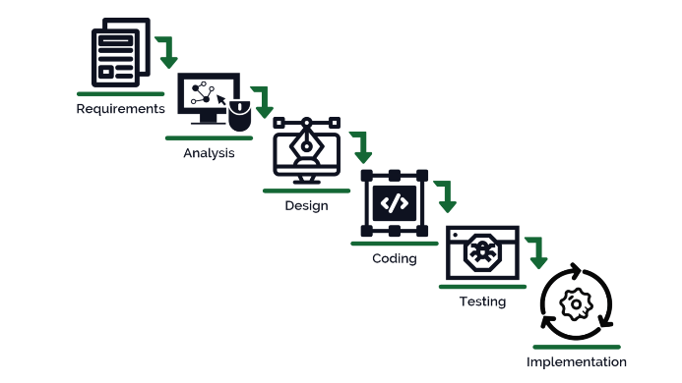

- System Requirement

- Hardware Requirement

- Laptop or PC
- MacOS Sierra and above (If Mac setup is required)
- Windows 7 or higher
- I3 processor system or higher
- 4 GB RAM or higher
- 100 GB ROM or higher

- Android Phone (6.0 and above)
- iPhone (iOS 9 and above) (If iOS version needs to be checked)

- Software Requirement

- Laptop or PC
- Android Studio with Flutter Plugin
- XCode (Latest version) (If iOS version needs to be checked on Mac)

- Limitation/Disadvantages
- Wrong inputs will affect the project outputs.
- Internet Connection is mandatory
- The android mobile user will not be able to insert or view details if the server goes down. Thus, there is disadvantage of single point failure.
- Assistance pickup status is not considered

- Application – This System can be used by Veterinaries and people who have pets to manage easy appointments and to locate vets

- Reference
- https://developer.android.com/
- https://stackoverflow.com/
- https://www.tutorialspoint.com/index.htm
- https://medium.com/

