Money Management App for Expense Planning Based on Flutter

- Background/ Problem Statement

Technological advancements, particularly in mobile technology, have been increasing in the modern era. As a result, as the number of mobile users grows, so will the number of mobile applications available to users.
Since November 2016, mobile devices have generated 48.19% more network traffic than desktops or laptops (47 per cent). A mobile application must become familiar with two distinct platforms in order to reach the majority of users: Android and iOS. These two platforms have significant differences that necessitate the development of different skill sets.
This project is written in Dart and is based on the flutter framework. Dart is a programming language that Google developed and keeps up with. A cross-platform framework for building high-performance mobile apps is called Flutter.
This Money Management System helps the user to track financial activity efficiently. It allows the user to set up the income and expenses from various options.

- Working of the Project

In Money Management System, it will enable the user to keep track of spending, adhere to a budget, and make savings. The user can choose to view the spending chart on a monthly or annual basis. using mobile money applications as a platform for managing money to help users develop a saving culture and to promote discipline.

The working of the application is the same for both the Android and iOS platforms.

In the dashboard, the user can view their total balance, monthly and annual expenses, and income. They can also view the expenses and income total category-wise.

It’s easy to add expenses to keep records, add income and update or delete any income or expenses. This system offers a graphical representation in the form of charts to help users understand and get a general sense of how money can be managed.

As this system helps manage money, when the expenses are beyond the certain set limitation or budget for the month, the user will be notified with a warning.

- Advantages

- helps with saving money, tracking spending, and sticking to a budget
- It provides charts to understand the expenses.
- The system is cross-platform.

- System Description
The system comprises 1 major module with a sub-module as follows:
User:
- Android App
- Dashboard
  - View Total Balance/Income/Expense Monthly/Annually
  - Expense/Income total category wise
- Add Expense
- Add Income
- Update/Delete
  - Update or delete any income/expense
- View Chart
- Set budget
  - When your expense increases the budget set for your month, you will be given a warning.
- iOS App

- Project Life Cycle

The waterfall model is a classical model used in the system development life cycle to create a system with a linear and sequential approach. It is termed a waterfall because the model develops systematically from one phase to another in a downward fashion. The waterfall approach does not define the process to go back to the previous phase to handle changes in requirements. The waterfall approach is the earliest approach that was used for software development.

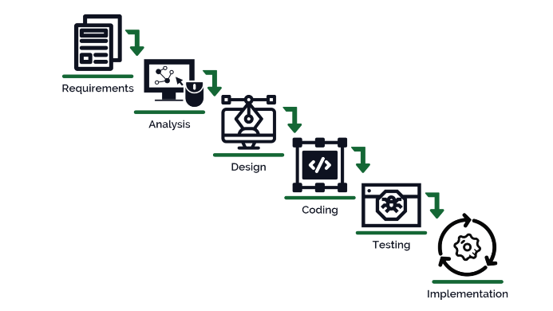

- System Requirements

- Hardware Requirement

- Laptop or PC
- macOS Sierra and above (If Mac setup is required)
- Windows 7 or higher
- I3 processor system or higher
- 8 GB RAM or higher
- 100 GB ROM or higher

- Android Phone (6.0 and above)
- iPhone (iOS 9 and above) (If the iOS version needs to be checked)

- Software Requirement

- Laptop or PC
- Android Studio with Flutter Plugin
- XCode (Latest version) (If iOS version needs to be checked on Mac)
- Azure Data Studio

- Limitation/Disadvantages
- If system data is cleared or uninstalled, all the data is lost.
- A new category cannot be added.
- Records greater than 1 year cannot be seen.

- Application – This system aids in money management; when expenses exceed a predetermined monthly budget or limit, the user is alerted with a warning.

- Reference
- https://www.researchgate.net/publication/269846460_Design_and_Implementation_Money_Management_Web_Based_Application_for_Personal_and_Family_Proposed_for_CV_X
- https://www.researchgate.net/publication/338342868_Development_Smart_Mobile_Money_Management_Application_for_Students

