Flutter AI Chatbot using Dialog Flow App

- Background/ Problem Statement

A chatbot is a computer programme that interacts with users using natural language or text, giving the impression that the user is conversing with an assistant. In order to produce the necessary response, most chatbots use Artificial Intelligence (AI) techniques.
Chatbots are now commonly used for a variety of corporate, personal, and educational purposes. Chatbots are user-friendly, and anybody who is capable of typing in a smartphone application may use them. Dialog Flow is a service which provides a complete product to implement voice- and text-based conversational interfaces. It employs Machine Learning to conduct a conversation as naturally as possible.
The whole process can be done using the simple UI in Dialog Flow’s console. There are many advantages which make Dialog Flow a compelling choice. Our Flutter-based AI Chatbot using Dialog Flow System will help the user to get answers to their questions by the chatbot.

- Working of the Project

In this system, the user will need to register first to log in to the system using a username and password. They can manage their profile by adding and updating their details and changing the new password. The user can chat with the bot, the chatbot will be trained in the dialog flow console. These questions and answers will be added to Dialog Flow Console directly.
Here, we have implemented a chatbot using Dialog Flow technology which will be helpful for the user to chat. Dialog Flow is a platform by google where we can design the chatbot what can be the question, how the chatbot will answer, related answers or modules etc.

This project is written in Dart and the database used here is SQLite, and it is based on the flutter framework. Dart is a programming language that Google developed and keeps up with. A cross-platform framework for building high-performance mobile apps is called Flutter.

- Advantages

- It is easy to maintain.
- It is user-friendly.
- The user can ask any sort of question and they will be answered by the bot.
- No need for human interaction and it saves time to reach people for clearing their doubts.

- System Description
The system comprises 1 major module with their sub-modules as follows:
User:
- Register
- The user needs to register first to log in to the system.
- Login
- They can log in using a username and password.
- Profile
- The user can add and update profile details.
- Change Password
- They also old change passwords to new ones.
- Chatbot
- Chatbot will be trained in the Dialog flow console.
- The user can chat with the bot.

- Project Life Cycle

The waterfall model is a classical model used in the system development life cycle to create a system with a linear and sequential approach. It is termed a waterfall because the model develops systematically from one phase to another in a downward fashion. The waterfall approach does not define the process to go back to the previous phase to handle changes in requirements. The waterfall approach is the earliest approach that was used for software development.

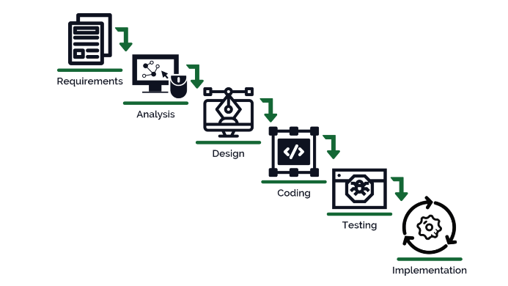

- System Requirements

- Hardware Requirement

- Laptop or PC
- macOS Sierra and above (If Mac setup is required)
- Windows 7 or higher
- I3 processor system or higher
- 8 GB RAM or higher
- 100 GB ROM or higher

- Android Phone (6.0 and above)
- iPhone (iOS 9 and above) (If the iOS version needs to be checked)

- Software Requirement

- Laptop or PC
- Android Studio with Flutter Plugin
- XCode (Latest version) (If the iOS version needs to be checked on Mac)

- Limitation/Disadvantages
- As there is no human interaction, the user has to deal with the answers by themselves, because there is no one to guide them.

- Application – This application helps to get answers to the question asked by the user by the bot.

- Reference
- https://www.researchgate.net/publication/336827160_Methodology_for_the_Implementation_of_Virtual_Assistants_for_Education_Using_Google_Dialogflow
- https://www.academia.edu/82044319/Ai_Chatbot_Using_Dialog_Flow
- https://easychair.org/publications/preprint_download/XdfZ

