Dental Caries Detection System using Python

- Background/ Problem Statement

Dental caries is the most common oral health condition. Some studies have shown that only 21% of people go to dental clinics and hospitals for dental examinations. The rate might be significantly lower in low- and middle-income countries where dental examinations are expensive and not covered by insurance.
Contrary to the accessible routine checkup, smartphones can be available and affordable in most countries. Thus, a smartphone-based diagnostic tool, which most of the population can easily access, could be a game changer in increasing the number of examinations of people with dental caries.
Deep learning, with a major model - Convolutional Neural Networks (CNNs), uses network structures consisting of multiple layers for automatically learning and self-learning backpropagation. Our python-based Dental Caries Detection System easily detects dental caries from an image uploaded by the user.

- Working of the Project

Deep learning with image input has been explosively growing and promising to become an important platform in medical images. One of its most popular applications in the medical field is classification. Applications of deep learning in dentistry are remarkable in a variety of fields such as teeth-related diseases, dental plaque, and periodontium.
Considering the anomalies in the existing system computerization of the whole activity is being suggested after the initial analysis. In this system, the user will need to upload an image from their device’s gallery. Once the user uploads an image, the system will proceed with detection by classifying if there are any caries present or not.
The front-end involves Html, CSS, and JavaScript and the back-end involves Python. The framework used is Django and the database is MySQL. The model used here is CNN and the dataset is extracted from Kaggle (consisting of two classes of carries and no carries).

- Advantages

- It is easy to maintain.
- It is user-friendly.
- The system can easily detect dental caries.
- The user will no longer need to take an appointment for a dental caries examination.

- System Description
The system comprises 2 major modules with their sub-modules as follows:

- USER:

- Register: The user will need to register first with their basic details.
- Login: They can log in using their username and password.
- Detection: Upload the image for detection and detection will proceed by classifying if there are carries or not.
- History: The user can view their previous detection in their history.

- ADMIN:

- Login: The admin can log in to the system using their username and password.
- History: They can view the history of detection with results done by users

- Project Life Cycle

The waterfall model is a classical model used in the system development life cycle to create a system with a linear and sequential approach. It is termed a waterfall because the model develops systematically from one phase to another in a downward fashion. The waterfall approach does not define the process to go back to the previous phase to handle changes in requirements. The waterfall approach is the earliest approach that was used for software development.

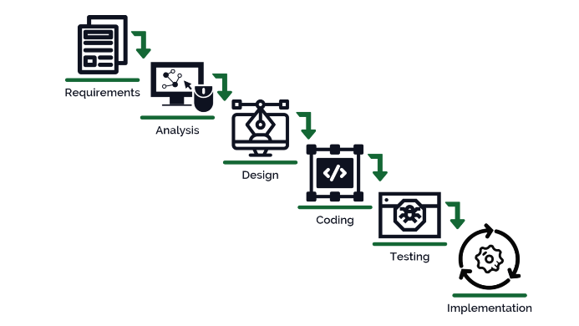

- System Requirements

- Hardware Requirement

- Laptop or PC
- Windows 7 or higher
- I3 processor system or higher
- 4 GB RAM or higher
- 100 GB ROM or higher

- Software Requirement

- Laptop or PC
- Python
- Sublime Text Editor
- XAMP Server

- Limitation/Disadvantages
- The system can only detect caries on good-quality images

- Application – This application can easily detect dental caries from an image.

- Reference
- https://www.mdpi.com/2076-3417/12/11/5504/pdf
- https://www.researchgate.net/publication/326641449_Detection_and_diagnosis_of_dental_caries_using_a_deep_learning-based_convolutional_neural_network_algorithm
- https://dl.acm.org/doi/10.1145/3473141.3473238

