AI Healthcare Bot System using Python

- Background/ Problem Statement

Today in the present era, the major challenges that India as a country is facing are to cater good quality and affordable healthcare services to its growing population and at the same time, they are not cost-efficient. This inaccessibility of healthcare facilities especially in rural areas and the difficulty in accessing means of transport causes patients to postpone their treatment, or option for medical facilities which is closer but at the same time are not cost-efficient and well-matched to their medical needs.
To tackle the above-mentioned problem, we have introduced an AI Healthcare Bot system. Our python-based system connects patients with the chatbot that will help them give the correct answers and precautions to their questions. It is developed with the aim to provide helpful information instantly, especially in times when every second is important. The system will also help the users find doctors, clinics, and hospitals nearby their location in emergencies.

- Working of the System

Our python-based project comprises 2 modules: User and Admin.

The user will need to register first to access the system. They can log in using their credentials after registering successfully. They can manage their profile and change the password if they want. The users can chat with the bot and resolve their health-related queries. They can also view doctors and their clinics near their location using Google places API. The users can also view hospitals nearby their location.

The admin can log in directly using their credentials to access the system. They can manage the question and answers and will require to train the model. They can also view the details of registered users.

We have created our own dataset to implement this system. Also, the CNN algorithm is used to develop this system. The accuracy of general disease risk prediction of CNN is higher as compared to other algorithms.

This system involves HTML, CSS and JavaScript in the front end and Python in the backend. The database used is MYSQL and the framework used is Django.

- Advantages

- The system will help provide answers to users’ health-related queries.
- It will help users find doctors, clinics or hospitals nearby their location.
- It will assist users in emergencies.
- The system is highly efficient and less time-consuming.

- System Description

The system comprises 2 major modules with their sub-modules as follows:
- User:
- Registration:
- The user would require to register first to log in.
- Login:
- They can log in using their credentials.
- Profile:
- They can manage their profile.
- Change Password:
- They can even change their password.
- Chat with Bot:
- The user can chat with the bot to get answers to their health-related queries.
- View doctors/clinics:
- They can view the list of nearby doctors/clinics using Google places API.
- View Hospitals
- They can also view the list of nearby hospitals using Google places API.
- Admin:
- Login:
- The admin can log in directly using their credentials.
- Manage Question & Answer:
- They can add, update, delete and view questions and answers along with keywords.
- They will also require to train the model.
- View Users:
- The admin can view the registered users.

- Project Life Cycle

The waterfall model is a classical model used in the system development life cycle to create a system with a linear and sequential approach. It is termed a waterfall because the model develops systematically from one phase to another in a downward fashion. The waterfall approach does not define the process to go back to the previous phase to handle changes in requirements. The waterfall approach is the earliest approach that was used for software development.

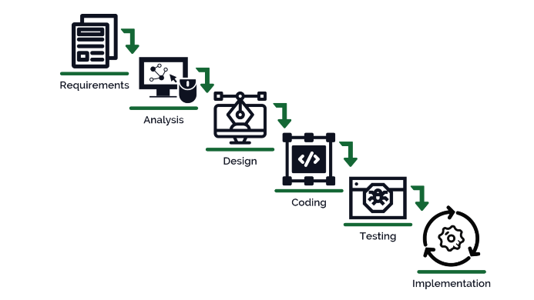

- System Requirements

- Hardware Requirement

- Laptop or PC
- Windows 7 or higher
- I3 processor system or higher
- 4 GB RAM or higher
- 100 GB ROM or higher

- Software Requirement

- Laptop or PC
- Python
- Sublime Text Editor
- XAMP Server

- Limitations/Disadvantages

- The system is purely AI-Based.
- Thus, resulting in fewer human responses.
- If any wrong data is entered, the system can produce inaccurate results.

- Application

- Our AI Healthcare Bot system is designed and developed to solve users’ health-related queries and find healthcare resources nearby their location.

- Reference

- https://www.matellio.com/blog/benefits-of-ai-chatbots-in-healthcare/
- https://www.jetir.org/papers/JETIR2204602.pdf
- https://ijcrt.org/papers/IJCRT2204694.pdf
- https://www.ijraset.com/research-paper/health-care-chatbot-using-nlp-and-flask
- https://www.ijert.org/research/a-chatbot-for-medical-purpose-using-deep-learning-IJERTV10IS050239.pdf

