College Placement System

- Background/ Problem Statement

From a student’s perspective, placements can bring a wide range of benefits and opportunities. Training and management of placement is a crucial part of an educational institution in which most of the work is done manually. Manual system in colleges requires a lot of manpower and time. Manual Training and Placement which is done at various colleges is by human intervention due to which there is a maximum chance of errors. The major problem is searching and updating student data.
To address the above-mentioned problem, we have developed a College Placement System. Our system can help to resolve the issue of manual work that makes the process slow and other problems such as inconsistency and ambiguity in operations. The system intends to assist college faculties and recruiting companies in analyzing the placement process more efficiently.

- Working of the System

The system comprises 3 modules: Students, Placement Department/Admin, and College Management.

The students would require to register first using their personal and academic details. They can log in using their email/username and password. They can view and update their profile and academic details. They can change their password if they want. The student can view both the ongoing as well as all the company recruitments along with the details and apply if they are eligible. They can view the list of the companies they applied to and check their status. They can also add and view off-campus jobs they have applied for and view their status. They can view the policy page. They can log out anytime they want.

The placement department admin can log in using their credentials. They can view both the ongoing as well as all the company recruitment lists along with their details on the Homepage. For placement, the admin can choose the course, branch and section. They can view the list and search for the students using the filter – by username/status (placed, etc). They can view the company and student details. They can update the status and upload the offer letter. The admin will have the access to add, update, delete and view the companies. They can enter the company details. They can add job descriptions, criteria, dates, eligibility, and more. For off-campus recruitment, the admin would require to choose the course, branch and section. They can view the list of students and search for a particular student using the filter – by username or status (placed, etc). They can add/view the off-campus applications along with the details of the status. They can view the statistics based on branches. They can view the graphical representation as students placed vs unplaced, students vs the number of jobs offered, companies and categories.

The college management admin can log in using their credentials. They can view both the ongoing as well as all the company recruitment list along with the details. They can view the students by choosing the course, branch and section. They can view the list and also search for a student by their username. They can view the student details as well. They can check the statistics based on the branch. They can view the graphical representation as students placed vs unplaced, students vs the number of jobs offered, companies and categories. They can view the off-campus application of the students who have been placed by choosing the course, branch and section. They can view the list of students and even search for a particular student using the username or status (places, etc). They can even check the policy page. They can log out anytime they want.

Note: There would be 3 categories – Mass, Core and Dream.

If you are placed in a higher category, you cannot apply for the lower one. Also, you cannot apply anywhere if you have been placed in 2 companies on campus.

The system’s front end involves HTML, CSS and JavaScript and the back end involves MySQL. The framework used is Django.

- Advantages

- The system provides students with a platform to access various job opportunities easily.
- It enables students to apply for jobs in various industries.
- It provides an opportunity for colleges to connect with a large network of employers.
- It offers a simplified recruitment process.
- It saves time and resources.

- System Description

The system comprises 2 major modules with their sub-modules as follows:
- Student:
- Registration:
- The student will require to register by adding their personal and academic details.
- Login:
- The student can log in using their email/username and password.
- Profile:
- They can view their personal/academic details and even update them in their profile.
- Change Password:
- The student can change their password if they want.
- Homepage:
- The student can view the ongoing company recruitments along with the details and can apply if eligible.
- They can also view all company recruitments along with the details and can apply if eligible.
- Placements:
- The student can view the list of the companies they have applied to and details about their status.
- Off-campus:
- They can add/view off-campus jobs they have applied for and details about their status.
- Policy (static page):
- They can view the policy.
- Logout:
- The student can log out anytime they want.

- Placement Department/Admin:
- Login:
- The placement department admin can log in using their credentials.
- Homepage:
- They can view the ongoing company recruitment list along with the details.
- They can view all company recruitment lists along with the details.
- Placements:
- The admin can view placements by choosing a course, branch and section.
- They can view the list of placements using filters - by USN / status (placed etc.)
- They can view the company and student details.
- They can update the status and upload the offer letter.
- Manage Company:
- The admin can add/update/delete/view companies.
- They can add the company details.
- They can view the job description, criteria, dates, eligibility etc.
- Off-Campus:
- They can view off-campus applications by choosing a course, branch and section.
- They can view the list of off-campus applications by using the filters - by USN / status (placed etc.)
- They can add/view off-campus applications and details about the status.
- Statistics:
- They can view the statistics based on branches.
- The graphical representations as placed vs unplaced, student vs number offered, companies and categories.
- Policy (static page):
- They can view the policy.
- Logout:
- The admin can log out anytime they want.

- College management:
- Login:
- The college management admin can log in using their credentials.
- Homepage:
- They can view the ongoing company recruitment lists along with the details.
- They view all the company recruitment lists along with the details.
- View students:
- They can search the students by choosing a course, branch and section.
- They can view the list of students by filtering by USN.
- They can view the student details.
- Statistics
- They can view the statistics based on branches.
- They can view the graphical representations as placed vs unplaced, students vs the number of jobs offered, companies and categories.
- Off-Campus
- They can view the off-campus applications by choosing a course, branch and section.
- They can view the list of jobs by filtering by USN / status (placed etc.)
- They can view off-campus applications of only those students who have been placed.
- Policy (static page):
- They can view the policy.
- Logout:
- They can log out whenever they want.

- Project Life Cycle

The waterfall model is a classical model used in the system development life cycle to create a system with a linear and sequential approach. It is termed a waterfall because the model develops systematically from one phase to another in a downward fashion. The waterfall approach does not define the process to go back to the previous phase to handle changes in requirements. The waterfall approach is the earliest approach that was used for software development.

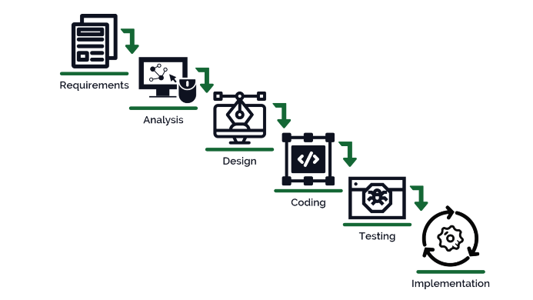

- System Requirements

- Hardware Requirement

- Laptop or PC
- Windows 7 or higher
- I3 processor system or higher
- 4 GB RAM or higher
- 100 GB ROM or higher

- Software Requirement

- Laptop or PC
- Python
- Sublime Text Editor
- XAMP Server

- Limitations/Disadvantages

- The system may have limitations on the location of job opportunities.

- Application

- Our College Placement System is typically used by colleges and universities to assist their students with finding employment after graduation.

- Reference

- https://cse.anits.edu.in/projects/projects1920C15.pdf
- https://www.researchgate.net/publication/319284117_Student_placement_analyzer_A_recommendation_system_using_machine_learning
- https://www.academia.edu/44867728/Placement_Management_System
- https://www.irjet.net/archives/V8/i6/IRJET-V8I6216.pdf

