Face Recognition Attendance System for Employees using Python

- Background/ Problem Statement

The face is the most important part of the human body because it uniquely identifies a person. Face recognition systems can be implemented by using facial characteristics as biometrics. Attendance tracking is the most difficult task in any organization.
Face recognition is a biometric technique that determines whether the image of a person's face matches any of the face images stored in a database.
The primary goal of this system is to build a face recognition-based attendance monitoring system for employees working in an organization in order to improve and upgrade the current attendance system to make it more efficient and effective than before. The employee should be in an area containing light so that the detection can be clearly made.

- Working of the System

The facial recognition feature embedded in the attendance monitoring system not only ensures accurate attendance but also eliminates flaws. Using a system to overcome defects not only saves resources but also reduces human intervention in the overall process by delegating all complex tasks to the system.
The employee will need to register first to use the system using their name, photo and other additional details. They can manage their profile and view their attendance on the system.
The admin can log in directly using their credentials. They can view the registered employees and their details. The system will mark the attendance of employees by detecting their faces using the webcam. The admin can view the attendance list of all the employees. They can even search for the attendance of any employees.
The front end involves Html, CSS, and JavaScript and the back end involves Python. The framework used is Django and the database is MySQL. Libraries like OpenCV, Dlib, and Face-Recognition are used here.

- Advantages

- No human intervention is required for marking attendance.
- The system recognises faces and records attendance.
- It prevents alteration with the attendance.
- The employee can also view their attendance.

- System Description
The system comprises 1 major module with their sub-modules as follows:
- Employee:
Registration:
- The employee will need to enter their username and capture a photo on the system.
- They will also need to enter additional details.
Login:
- The employee can log in using their credentials.
Profile:
- The employee can manage their profile.
View Attendance:
- They can view their attendance here.

- Admin:
Login:
- The admin can log in using their credentials.
View Employees:
- The admin can view the registered users.
Attendance:
- The webcam will open and attendance will be marked after the employee’s face is detected.
View Attendance:
- The admin can view the attendance list of all the employees.
- They can even search for an employee’s attendance by their name.

- System Life Cycle

The waterfall model is a classical model used in the system development life cycle to create a system with a linear and sequential approach. It is termed a waterfall because the model develops systematically from one phase to another in a downward fashion. The waterfall approach does not define the process to go back to the previous phase to handle changes in requirements. The waterfall approach is the earliest approach that was used for software development.

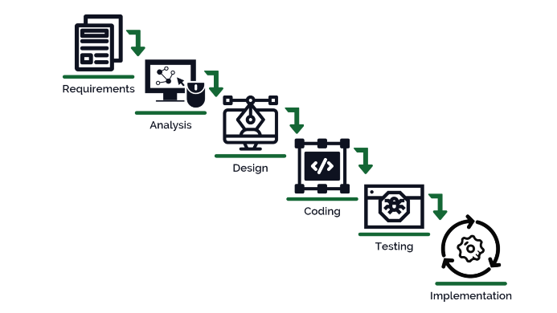

- System Requirements

- Hardware Requirement

- Laptop or PC
- Windows 7 or higher
- I3 processor system or higher
- 4 GB RAM or higher
- 100 GB ROM or higher

- Software Requirement

- Laptop or PC
- Python
- Sublime text Editor
- XAMP Server

- Limitations/Disadvantages
- To detect a face, the candidate must be in an area with light; otherwise, it will not be able to detect it.

- Application
- This application is a face recognition-based attendance monitoring system for organisation employees.

- Reference
- https://www.irjet.net/archives/V7/i12/IRJET-V7I12377.pdf
- https://www.questjournals.org/jses/papers/Vol5-issue-2/D05021829.pdf
- https://www.researchgate.net/publication/341870242_Smart_Attendance_System_using_OPENCV_based_on_Facial_Recognition
- https://www.researchgate.net/publication/352393875_Attendance_Management_System_using_Face-Recognition

