Online Voting System Project Python

- Background/ Problem Statement

Democracy is an important matter in most modern societies. One of the most important activities in a democracy is the election of representatives. It is also a very delicate process that is subject to various disturbances, such as inactive citizens, fraud attempts, etc. The problem of voting is still critical in terms of safety and security.
We have designed an Online Voting System in Python to tackle the existing problem of elections in various spaces. It is a web-based voting system that will help to manage elections easily and securely. This voting system can be used for casting votes during elections held in universities and organizations. In this system, the voter does not have to go to the polling booth to cast their vote. They can use their personal computer for doing so. The system can be used anywhere. It is not just employed for national elections; it may also be used for any sort of elections required.

- Working of the System

The system comprises 2 modules: User and Admin.

The admin can log in using their credentials. They will have the access to add, update, delete and view elections. They can also add candidates. They can either choose candidates from the registered users or add new ones. They can view the votes cast by the users and the winner of the elections.

The user would require to register first to access the system. They can log in using their credentials. They can manage their profile and change their passwords. The users can view both the ongoing and expired elections along with their details and candidates. For ongoing elections, the user can cast their votes and for expired elections, they can view the winners.

This system involves HTML, CSS and JavaScript in the front end and Python in the backend. The database used is MySQL and the framework used is Django.

- Advantages

- It helps to conduct elections easily.
- The voters can cast vote from the comfort of their homes.
- The voters don’t have to wait in a queue to cast their votes.
- The system works efficiently.
- It is also less time-consuming.

- System Description

The system comprises 2 major modules with their sub-modules as follows:
- Admin:
- Login:
- The admin can log in using their credentials.
- Manage Election:
- They can add, update, delete and view elections.
- They can add, update, delete and view candidates.
- They can either choose from registered users or add new candidates.
- They can also view the votes cast by the user and the winners of the elections.
- User:
- Register:
- The user would require to register first.
- Login:
- They can log in using their credentials.
- Profile:
- They can manage their profile.
- Change Password:
- They can also change their password if they want.
- View Elections
1. Ongoing:
- The user can view the list of ongoing elections.
- They can check the details and candidates of any particular election.
- They can cast their votes here.
2. Expired
- The user can view the list of expired elections.
- They can view the details and candidates of any particular expired election.
- They can also view the winner of that election.

- Project Life Cycle

The waterfall model is a classical model used in the system development life cycle to create a system with a linear and sequential approach. It is termed a waterfall because the model develops systematically from one phase to another in a downward fashion. The waterfall approach does not define the process to go back to the previous phase to handle changes in requirements. The waterfall approach is the earliest approach that was used for software development.

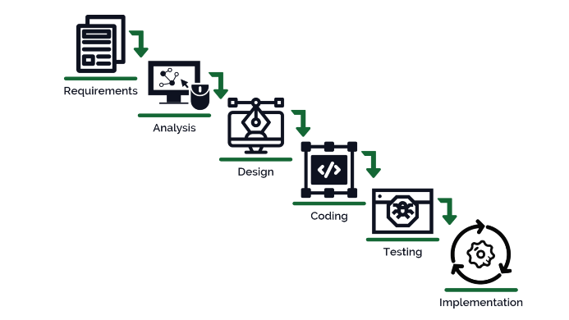

- System Requirements

- Hardware Requirement

- Laptop or PC
- Windows 7 or higher
- I3 processor system or higher
- 4 GB RAM or higher
- 100 GB ROM or higher

- Software Requirement

- Laptop or PC
- Python
- Sublime Text Editor
- XAMP Server

- Limitations/Disadvantages

- There are chances of voters’ or candidates’ accounts getting hacked.
- If any data is entered wrong, the system can produce inaccurate results.

- Application

- Our Online Voting System is developed to conduct votes and elections securely. It is not only limited to national elections but can be used to conduct general elections.

- Reference

- https://transmitter.ieee.org/makerproject/view/91d35
- http://www.diva-portal.org/smash/get/diva2:443096/fulltext01
- https://electionbuddy.com/blog/2022/04/20/the-advantages-and-disadvantages-of-online-voting-systems/
- https://www.irjet.net/archives/V4/i12/IRJET-V4I12256.pdf

