Blockchain-based Disk Space Rental System

- Background/ Problem Statement

The majority of disc space on a computer is free; however, if a company pays money to rent out hard-disk space, the company can then rent that space to other businesses. To overcome data loss, the application must be extremely sophisticated, taking into account the net speed and duplicating data on multiple renters.
Increased security in hostile environments is just one of the many advantages that blockchain technology offers in a wide range of industries.
Blockchain is a linked list that employs Hash Pointers rather than regular pointers. This allows each blockchain node to not only locate the next node but also verify whether the data in that node has changed. Here, the data is divided into multiple sections across multiple renters, so no one knows what the data is except the service provider.
The principle is free-market between data owners, who need disk space to store/backup private data, and disk space owners, who provide disks for that purpose.
File Storage Marketplace is absolutely decentralized, unlike traditional storage. The main purpose of the system is to provide a public, decentralized and secure disk space renting platform.

- Working of the Project

In Disk Renting System, to log in to the system the admin can log in with a username and password. The admin checks the requests from the user for renting disk space.

Admin has the authority to accept or reject the request. And if the request is been accepted by the admin, then the user will be assigned disk space. The admin can check for system manipulations by viewing Transactions, Payments, and Disk usage.

The user has to register their account and log in using a username and password. The user can view their total hard disk usage, their total space rented, and their total space unused.

The user then views a list of all available hard disks and needs to request permission from the admin to rent the space. The user can look for plans for hard disks, purchase one, and check if any request manipulations have been made.

- Advantages

- Due to the encryption feature, Blockchain is always secure.
- Blockchain data structures harden network security by reducing single-point-of-failure risk, making a database breach difficult.
- Blockchain eliminates unauthorized access, each user in the blockchain has their key.
- It prevents data tampering.

- System Description
The system comprises 2 major modules with their sub-modules as follows:
- Admin:
  - Login
  - Space
  - Pending Request
    - Accept/Reject
  - Accepted ones
    - Assign Space to User
  - Transactions
    - Payments & disk used
    - check for any manipulations

- User:
  - Register
  - Login
  - Profile
  - CP
  - Home
    - Total Hard disk Used
    - Total Space Rented
    - Total Unused Space
  - Rent Space
    - List of all the Hard disk
    - Approval is needed from the admin
    - Add/Update/delete/view
  - Buy Space
    - Search & buy a plan
    - Pay
  - Transactions
    - Payments & disk used
    - check for any manipulations

- Project Life Cycle

The waterfall model is a classical model used in the system development life cycle to create a system with a linear and sequential approach. It is termed a waterfall because the model develops systematically from one phase to another in a downward fashion. The waterfall approach does not define the process to go back to the previous phase to handle changes in requirements. The waterfall approach is the earliest approach that was used for software development.

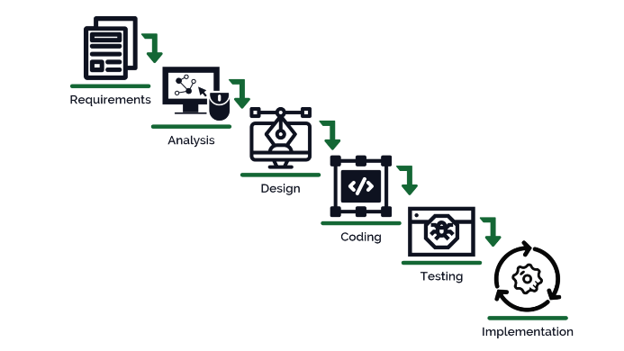

- System Requirements

- Hardware Requirement

- Laptop or PC
- Windows 7 or higher
- I3 processor system or higher
- 4 GB RAM or higher
- 100 GB ROM or higher

- Software Requirement

- Laptop or PC
- Visual Studio 2019
- SQL Server Management Studio latest

- Limitation/Disadvantages
- Blockchains, for example, have lower efficiency and demand more storage space when compared to conventional centralised databases.

- Application – The Disk Space Renting System’s main objective is to offer a public, decentralised, and secure platform for renting disc space.

- Reference
- https://ieeexplore.ieee.org/stamp/stamp.jsp?arnumber=8400511
- https://www.deac.eu/news/blog/disk-space-rental-risks-and-advantages/en/
- https://github.com/AndriianChestnykh/fsmp#:~:text=Main%20purpose%20of%20the%20system,provide%20disks%20for%20that%20purpose.

