Blockchain-based Loan Management System with Smart Contracts

- Background/ Problem Statement

n this paper, we proposed a loan management system based on blockchain namely
DApp. In real-time, the system securely shares the details about transactions by
organizing the network, this action prevents the fraudsin the system. Our proposed
system maintains the privacy of the valuable customers by eliminating the attackers or
frauds who injecting vulnerable data. By our proposed system, the banks in India can
be completely digitalized without any hesitation from the hackers and the attackers.
Thus, the integration of blockchain in the loan management system incorporates easier,
faster, and cheaper solutions, which can be adapted by the existing banking systems for
experiencing the high-level security and privacy.
Providing a loan should be a simple process. One should check the client’s eligibility to get the loan and then approve or deny the loan. Once approved, the customer should receive the funds. However, in traditional systems, this process is often chaotic for valid reasons. As the customer base increases, servicing loans becomes complex.
Every customer has different terms and payment dates. Loan management systems help automate the entire loan lifecycle. A blockchain offers different protocol networks so the development of the blockchain and its transactions do not interfere with live transactions. These networks are used to develop, test, and deploy smart contracts and other transactions.
Our Loan Management System based on blockchain with smart contract securely shares the details about transactions by organizing the network, this action prevents fraud in the system. In cirrus’s core wallet, the admin creates an account for each user and updates the wallet information in their profile and the transaction is done using the Cirrus API.

- Working of the Project

In this system, the admin can log in/log out from the system. They have the authority to view, approve, block and delete the customers and manage their requests for a loan. The list of all the customers can be viewed by the admin those who have requested approval from the admin and a contract will be created. The loan amount can also be transferred to the customer.
The system will list down all the customers who have successfully received loans and their payoff details to the admin. All the transactions done by the customers can be viewed by them. Cirrus Core dashboard contains all the information about cirrus core and the wallet details of customers and the admin and they can view all the feedback of all the customers.
The customer will need to register to log in to the system to apply for a loan. The system will display the reminder of the pay-off date. The customer can request a loan by sharing all their details such as the reason for a loan, amount, duration of pay-off, personnel and income details. The contract details and the transaction loan amount details can be viewed by the customers.
All the transaction history can be viewed and the customer can share their feedback with the admin. In this project, the front-end involves Html, CSS, and JavaScript and the back-end involves ASP.NET. The IDE used is Visual Studio and the database is MSSQL.

- Advantages

- It is easy to maintain.
- It is user-friendly.
- The customer can easily apply for a loan.
- The integration of blockchain incorporates easier, faster, and cheaper solutions.
- The system maintains the privacy of valuable customers by eliminating attackers or frauds who inject vulnerable data.

- System Description
The system comprises 2 major modules with their sub-modules as follows:
- ADMIN

- Login
  - The admin needs to log in to the system using login credentials.
- Manage Customer
  - Admin can view, approve, block and delete the customer from the system.
- Manage Loan Requests
  - The loan requests are listed here.
  - Admin can view, approve and delete the loan requests.
- Create Contract
  - The customers who have requested approval from the admin will be listed and the contract will be created.
  - Also, the loan amount can be transferred from this module.
- Customer's Details
  - The list of customers who successfully received loans and their payoff details can view by the admin.
- Transaction History
  - The admin can view all the transactions made by customers.
- Cirrus Dashboard
  - The cirrus dashboard will contain information about cirrus core wallet details of customers.

- View Feedback
  - Admin can view feedback of all customers.
- Logout
  - The admin can log out from the system after finishing their work.

- CUSTOMER

- Login
  - The customer will log in to the system using their login credentials.
- Register
  - They will need to register to the system to apply for a loan.
- Home
  - The main page of the customer module system will show the reminder of the pay-off date here.
- Loan Request
  - Customer can request a loan with details like (reason, amount, Duration to pay off, Personnel and Income details).
- Contract Details
  - Customer can view the Contract Details (Date, Time, Duration, Interest amount, Loan amount, Admin wallet details) and the transaction of loan amount details.
- Make Transaction
  - Customer can make transactions from this module.
- Transaction History
  - The transactions history will be listed in this module.

- Feedback
- The customer can share their experience of using the system and suggestions about the loan facilities.
- Logout
  - The customer can log out from the system after finishing their work.

- Project Life Cycle

The waterfall model is a classical model used in the system development life cycle to create a system with a linear and sequential approach. It is termed a waterfall because the model develops systematically from one phase to another in a downward fashion. The waterfall approach does not define the process to go back to the previous phase to handle changes in requirements. The waterfall approach is the earliest approach that was used for software development.

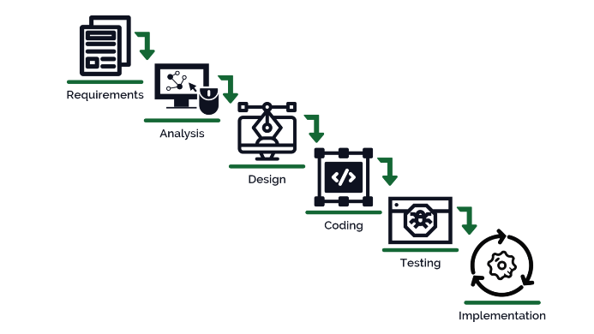

- System Requirements

- Hardware Requirement

- Laptop or PC
- Windows 7 or higher
- I3 processor system or higher
- 4 GB RAM or higher
- 100 GB ROM or higher

- Software Requirement

- Laptop or PC
- Visual Studio 2019
- SQL Server Management Studio’s latest

- Limitation/Disadvantages
  - The user must add all their personal details and valid reason when applying for the loan, otherwise, the loan will get rejected.

- Application – This application helps in loan management and provides loan transaction security.

- Reference
  - https://www.researchgate.net/publication/333253621_LoC_-_A_new_financial_loan_management_system_based_on_smart_contracts
  - https://www.researchgate.net/publication/355347165_Decentralized_Loan_Management_Application_Using_Smart_Contracts_on_Block_Chain
  - https://www.sciencedirect.com/science/article/abs/pii/S0167739X18324233

